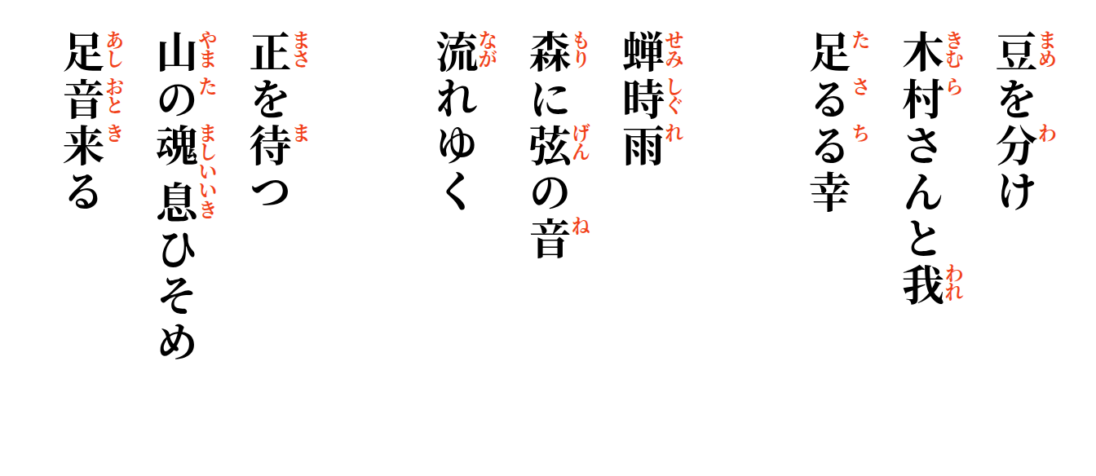

We wait for Masa-san
the mountain holds its breath
until footsteps come.

A handful of beans shared with Kimura-san and me—
enough for joy.
Frogs lift the first tune,
cicadas weave violin strings
through the deep forest.

